**IT2120 - Probability and Statistics**

**Lab 06**

**Bandara L.M.I.L**

**IT24100330**

Exercise

1.

i.

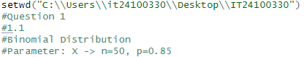ii.

2.

i.

ii.

iii.

